Bias Tape Jigs

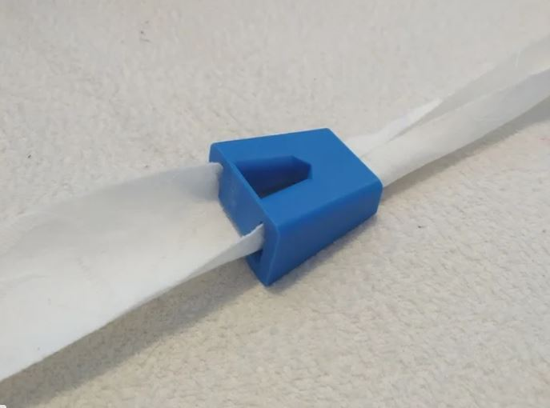

This simple little piece of plastic helps someone fold a strip of cloth together for sewing, and contributes to a good portion of a cloth face mask. You can use this to produce masks much faster and easier.

Great video demonstrating how to use tool on You Tube:

# How to quickly make bias tape for emergency masks

Direct Link: <https://www.youtube.com/watch?v=GRcYgfxQZLo>

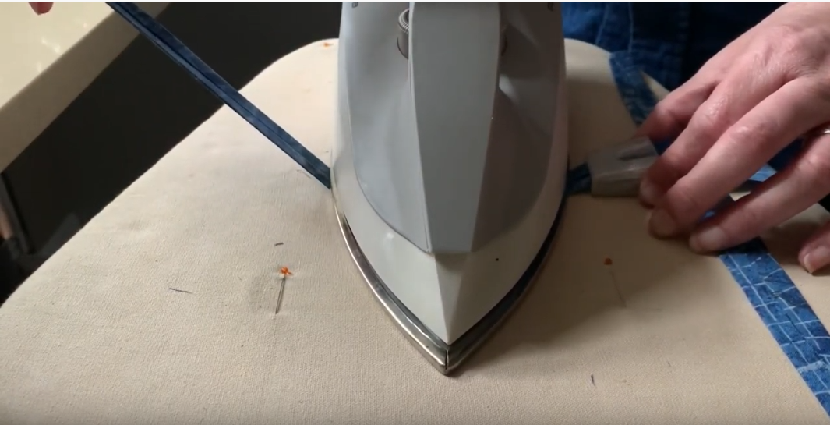

Sizes included:

Large = 5cm Small = 4cm

Thank you for all you’re doing to help the healthcare workers!

Please text or email for questions or comments.

Email: ­­ Cell: